Edge Intelligence
D. Sai Mohith
25MML0032
Task-1:
Key Take aways:
- Analysing an image dataset-MNIST and applying basic preprocessing operations,
- Applied Artificial neural network on the following dataset.
- Saving the model using pickle model.
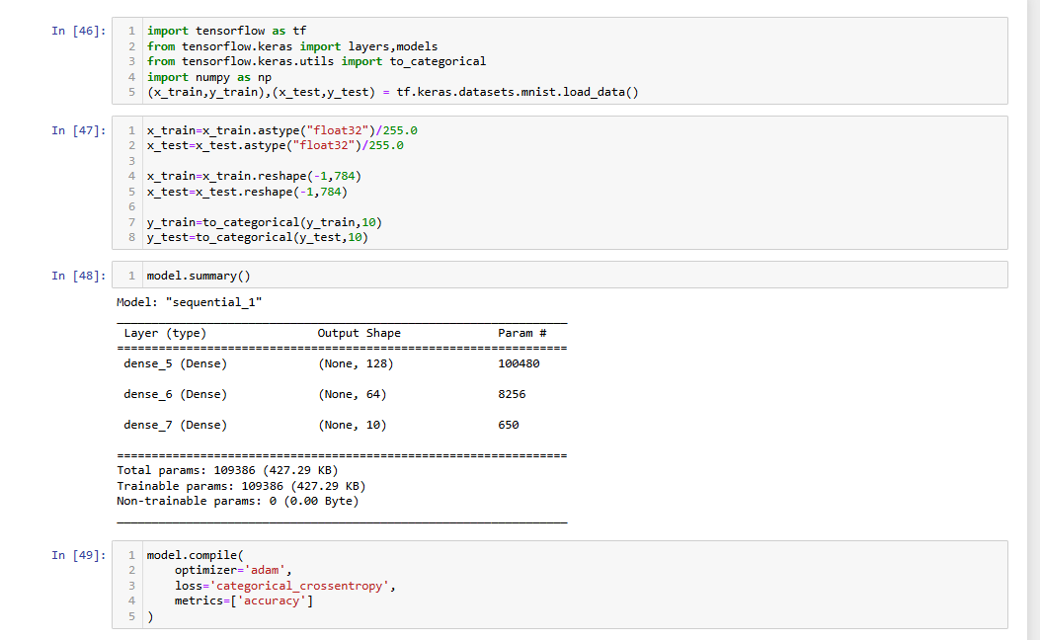

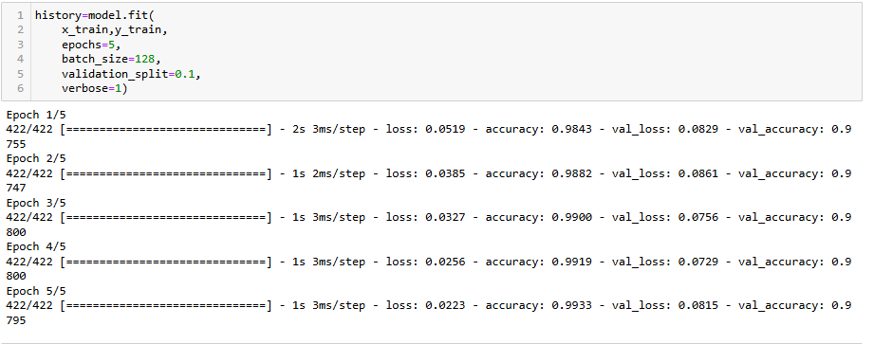
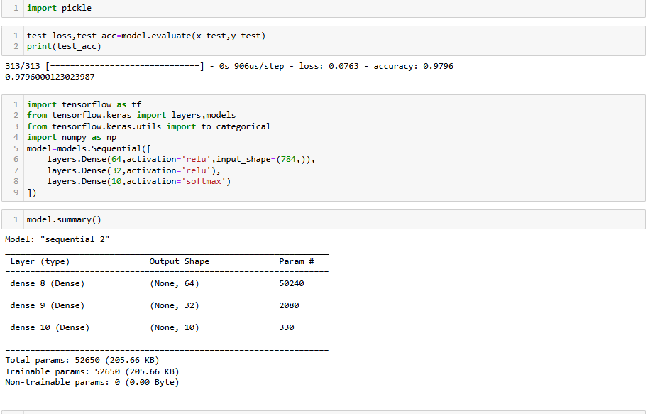

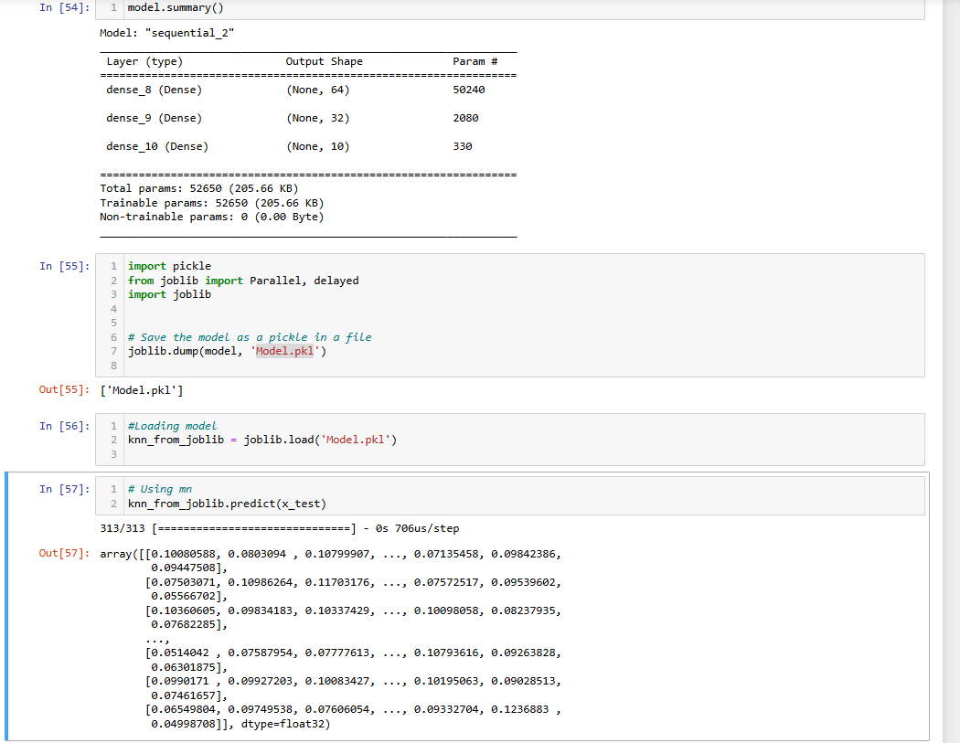

Task-2
Steps to collect the data are listed below in detail:
- Make an Edge Impulse account
Initially, go to the Edge Impulse website and register for a new user account using your email address or one of the accepted login credentials. After registering successfully, access the Edge Impulse Studio dashboard. Projects, datasets, and model training all require this account.
- Visit the section on data acquisition
Create a new project or open an existing one after logging in. Go to the Data Acquisition tab on the project dashboard. The raw data (pictures, audio, or sensor data) that will be used to train the machine learning model is gathered and uploaded in this step.
- Select the "Connect Data" option.
Choose Connect Data from the Data Acquisition page. This enables you to directly gather data from Edge Impulse by connecting external devices like a computer, development board, or cell phone.
- Use your phone to scan the QR code.
Edge Impulse shows a QR code on the screen after choosing the connect option. Scan this code using your smartphone's camera or QR scanner. This allows you to take and upload data straight from your phone by connecting it to the Edge Impulse project.
- Prior to clicking a picture, choose Label Data
Select the proper label (class name) for the data before taking any pictures, such as "cat," "dog," or "car." Accurately labelling the data at the time of collection is crucial since it aids the machine learning model in comprehending the meaning of each image.

- Divide the recorded images into training and testing sets
Once the photos have been gathered, separate the dataset into training and testing sets.

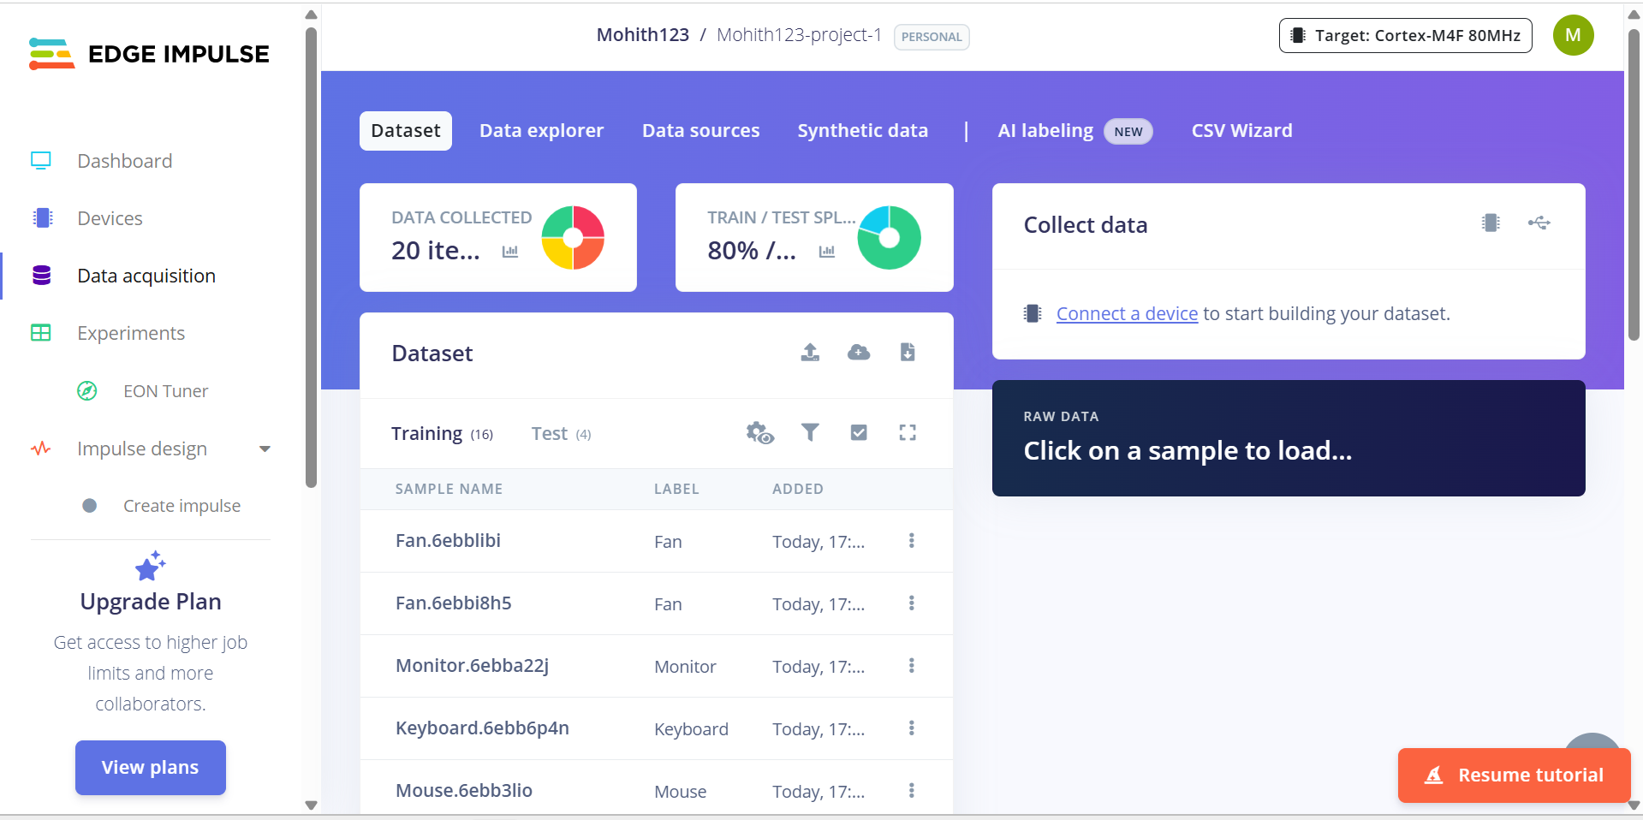
Total pictures are 20 out of which 16 are for training and 4 are for testing ie 80:20 ratio
